Happy Monday,

We’ve had a strong start to the month, averaging around 8k a day, which we need to get up and over 10k to reach out 300k+ goals.

We are trending upwards, with 14% growth in Search and 2.2% social.

Traffic acq:
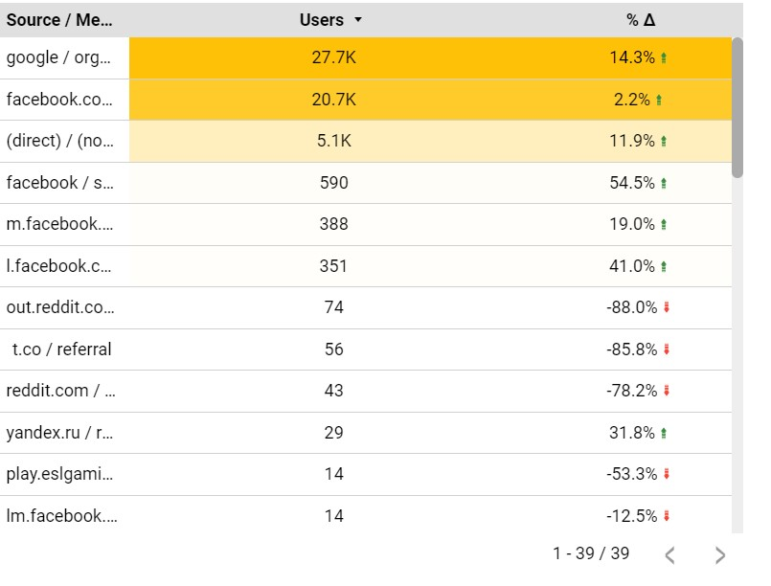
Top 10:

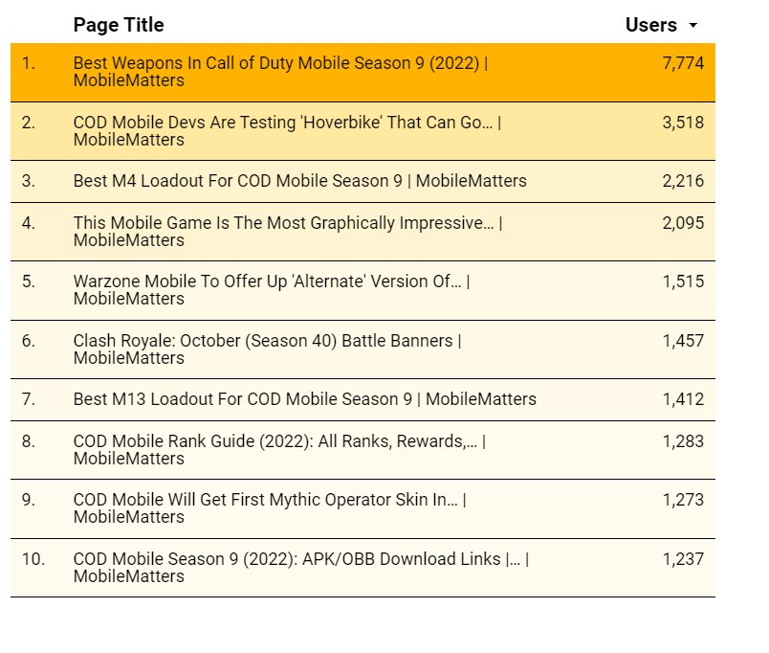
This is all positive, just need to keep working hard and adding to our baseline numbers. Plenty of opportunities to do that this week, and through the month.

Redeem Code Stories - Google Sheets

Content

Content wise, it is a MASSIVE week. COD: Mobile Season 10 is my (Daniel) main focus, looking to take an even bigger share of the traffic than last major update.

It is also a bigger update than previous ones, plenty of guides, news, and surprises to come for this.

Monday:

- Brawl Stars new season
- Clash Royale new season

Wednesday:

- Free Fire Weekly Schedule
- Legends of Runeterra patch 3.19
- Wild Rift Champions Rotation

Friday:

- Asphalt 9 Car Hunt

Videos

Day 7 of the Brawl Stars SPS Season 2 EU & MENA tournament will be held on Tuesday. We’ll be making videos on that.

Clash Royale started their first few Split rounds for the Open Finals in season 2 of SPS. We’ll get on that too.

Social Media

Another solid week for Facebook. A 4k increase in followers and extra 50k organic reach from last week.

We didn’t have a viral article last week so it’s great that our overall organic reach was about 150k. In the past, we weren’t able to break the 100k threshold without having a viral piece. This just shows how big last week was in terms of content.

COD Mobile, Wild Rift, and Marvel Snap pieces attracted the most attention from our audience.

